CS 255 System Design Document Template

This template lays out all the different sections that you need to complete for Project Two. Each section has guidance to prompt your thinking. You will need to continually reference the interview transcript as you work to make sure that you are addressing your client’s needs. There is no required length for the final document. Instead the goal is to complete each section based on what your client’s needs are. Remove this note when you are finished, and replace all bracketed text with the relevant information.

UML Diagrams

UML Use Case Diagram
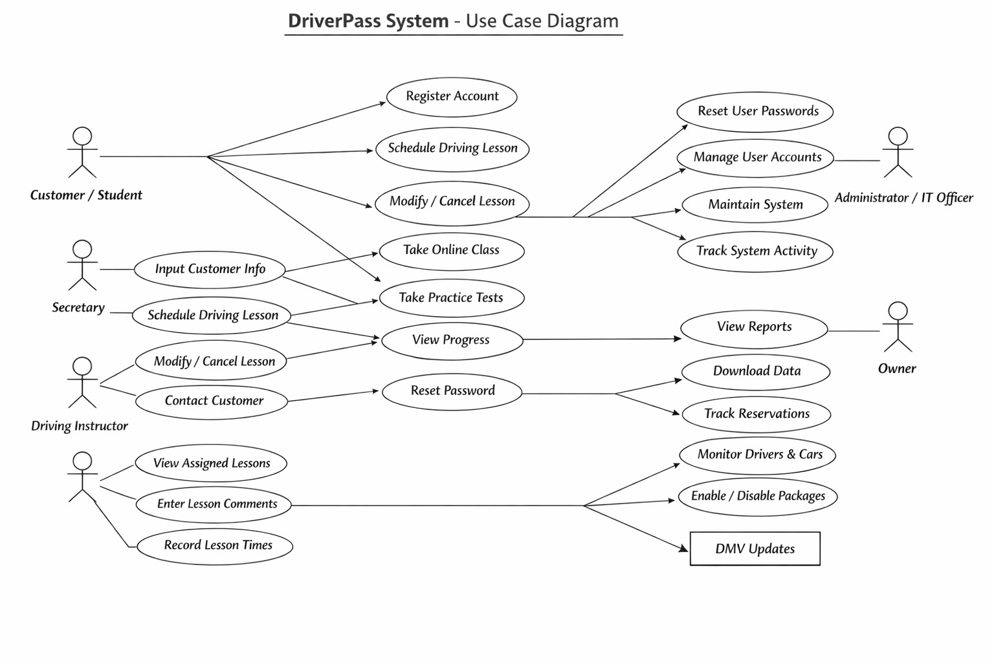

UML Activity Diagrams
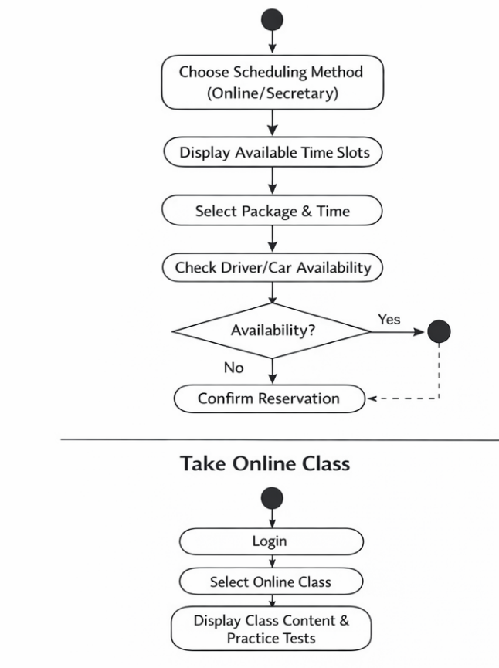

UML Sequence Diagram
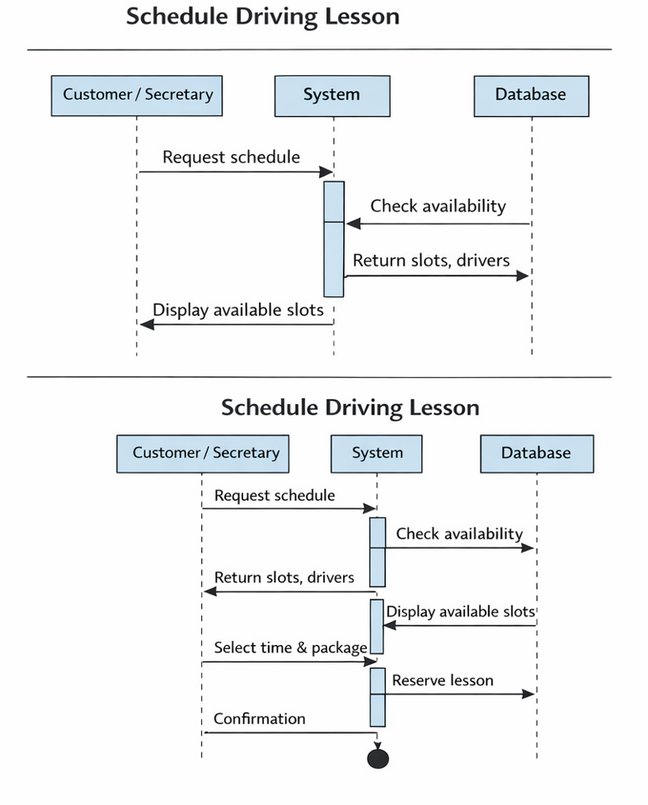

UML Class Diagram
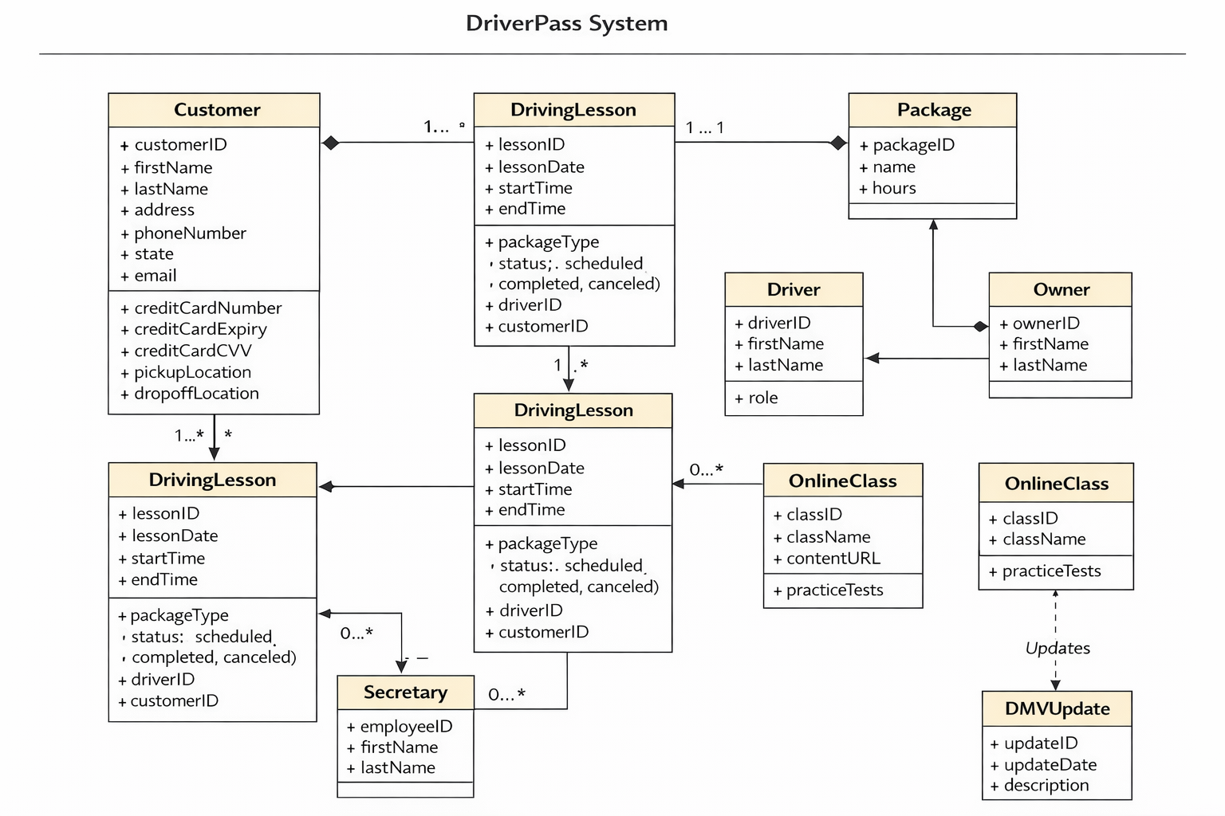

Technical Requirements
Hardware Requirements
For the Server / Cloud Environment:
- Web Server: To host the application (e.g., Apache, Nginx, or cloud-based services like AWS EC2, Azure App Service)
- Database Server: For storing customer, lesson, driver, and package information (e.g., MySQL, PostgreSQL, or cloud databases like AWS RDS)
- Backup Storage: Automated backups of databases and system files
- Network Infrastructure: High-speed internet connectivity, firewalls, and load balancers for scalability
For Users:
- Customer Devices:
  - Desktop or laptop with internet browser (Chrome, Edge, Firefox)
  - Mobile devices (smartphones/tablets) for online registration, scheduling, and classes
- Employee Devices (Secretary, Administrator, Drivers):
  - Desktop or laptop
  - Optional tablets for drivers to record lesson notes on the go

Software Requirements
Operating Systems:
- Server: Linux (Ubuntu, CentOS) or Windows Server
- Client: Windows, macOS, iOS, Android for web access
Application Software:
- Web Application Framework: Supports online registration, scheduling, and classes (e.g., Django, Flask, Node.js, ASP.NET)
- Database Management System (DBMS): MySQL, PostgreSQL, or Microsoft SQL Server
- Frontend Technologies: HTML, CSS, JavaScript, React or Angular for responsive interface
- Security Software: SSL/TLS certificates, antivirus, firewall management
Supporting Software / Tools:
- Reporting Tools: Export reports in Excel or PDF
- Email / Notification System: For appointment confirmations and DMV updates
- Integration Tools: API connectivity for DMV updates

Tools & Development Environment
- UML Design Tools: Lucidchart, draw.io for diagrams
- IDE / Code Editors: VS Code, PyCharm, WebStorm
- Version Control: Git and GitHub/GitLab for source code management
- Testing Tools: Selenium, Postman for web and API testing
- Project Management Tools: Jira, Trello for task and schedule tracking

Infrastructure Requirements
- Cloud Hosting / SaaS: Host the application and database in a cloud environment to ensure availability, scalability, and redundancy
- Data Security & Backup:
  - Role-based access control for employees (Administrator, Secretary, Owner)
  - Daily automated backups of database and application
  - Encrypted storage for sensitive customer data (credit card info, personal details)
- Connectivity:
  - Internet access required for all users accessing online classes, scheduling, and DMV updates
- Monitoring & Logging:
  - Track system activity (lesson scheduling, modifications, cancellations)
  - Error logging and alerting for system failures

Optional / Future-Proofing Requirements
- Mobile Application: Native iOS/Android apps for customers and drivers
- Analytics Dashboard: For Owner to monitor reservations, progress, and employee performance
- Scalable Architecture: Microservices or modular design to add new packages, online classes, or features in future
- Integration with Payment Gateway: For secure processing of credit card payments

